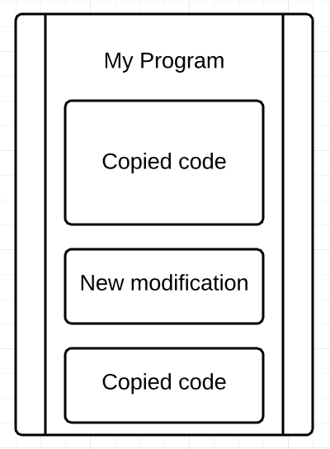A reminder of Level 3 and 4. However, this level motivates to make more predictions about future behavior of the character. As foreseeing the result is one of the top skills a good programmer requires, our game develops it having growing difficult with each new level.

This level is also to show you that similar code can be used for different application. Programmers do not need to remember particular algorithm or function, they can always Google it. However, it is viable to have the skill to quickly recall previously used algorithms. In order to succeed, you are advised to have a copy of all your documents with personal explanation comments in it. This way, you can easily access necessary coding part anytime it is required to.

In some way, University College London teaches this skill, though in an indirect manner. Students are asked to solve certain problem; and then, after a few months, there is a new task which involves your previous solution with an addition of some moderations. What some students would do is to completely rewrite the algorithm twice, but organised files may help you to not repeat your work. *See Figure 1 for further reference.*

Figure 1: Ways to program